Translation
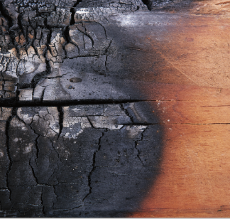
Yakisugi – trend meets tradition
The name Yakisugi is a combination of the Japanese words yaki, meaning
to burn and sugi, which is Japanese Cedar. It is a traditional method of
preserving wood by charring the surfaces. The heat treatment by open fire
prolongs the life of the wood by preventing rot and insect infestation,
making the boards more dimensionally stable and giving them a very
distinctive appearance. Yakisugi, classic in Japanese architecture, is now
also finding its way in to Europe.

焼 杉= Yakisugi

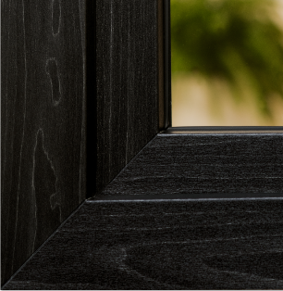
RENOLIT EXOFOL PX Yakisugi –
Far Eastern style for your home
The new RENOLIT EXOFOL PX Yakisugi decor is inspired by the ancient Japanese technique combined with classic design characteristics of the local architecture. The black, interspersed with silvery shades, sets a deliberate contrast to light woods,
colours and designs. In addition, the surface – like its natural counterpart – is characterised by high dimensional stability, colour fastness and durability.

OUR JOURNEY TO NEW TRENDS
We humans always experience ourselves as limited in body and soul.
Therefore, “man is a journey”, as the poet Novalis stated.
Curiosity drives us humans to constantly discover new spaces and expand our horizons.
We want to explore the unknown in order to gain new experiences that delight our senses
and open up new perspectives. The journey, the travel, knows no end.
Our trend service Colour Road has also been travelling. Its Trend Report 2022/23 TRAVELLING INTO NEW DIMENSIONS takes us on a colour journey that is as imaginative as it is fascinating.
One of the discoveries, made in the Far East, is the traditional technique of “Yakisugi”,
and its distinctive style has already found its way in to Europe. Now we are embracing it
to open up new horizons in the design of windows and put them in a whole new light.
Spot on trend, then, our new décor RENOLIT EXOFOL PX Yakisugi.

Find out more about the RENOLIT Colour Road trend service at renolit.colourroad.com

