PRESS RELEASE
Renolit SE
Market Unit
Exterior Solutions
Horchheimer Straße 50
67547 Worms/Germany
www.renolit.com

Your contact:

xxxx
xxx
Phone.: + xxx
Fax: + xxx
xxx

A new direction in colour design

The new RENOLIT EXOFOL colours and décors are in step with the Colour Road Trendservice

Worms, 1. April 2022 – Trends are no coincidence, be they in architecture or fashion, shapes or colours. Rather, they are the reflection of social themes and socio-cultural trends. The RENOLIT Trendservice Colour Road gets to the bottom of these subjects, analyses them in cooperation with international trend institutes and colour experts and derives future colour trends in surface design from them.

In an annual trend report, the RENOLIT Corporate Design Management team summarises its findings and categorises the trend colours into individual colour worlds. The Trend Report 2022/23 "Travelling into new dimensions" features the colour worlds of "Deep Ocean Level" and "Cosmos Level". We will be using these findings to select colours for RENOLIT EXOFOL products in the future.

When assigning colours to different areas of application, the Colour Road team takes into account the specific surrounding areas. "On windows and façades, colours tend to have a more intensive effect than in interiors because they are in direct light and the surrounding building,” explains expert Clarissa Blüm. It is also important to keep in mind the longer "service life" of the building envelope, because the life of a façade or window design tends to be measured in decades.

New décor RENOLIT EXOFOL PX Yakisugi
RENOLIT EXOFOL PX Yakisugi opens up a new dimension in window design. The exotic and natural appearance is inspired by an old Japanese technique for preserving wood - the name Yakisugi stands for "burn" and "Japanese Cedar". The heat treatment by open fire prolongs the life of the wood and gives it a very distinctive look. The black of the new décor, interspersed with silvery shades, reflects this charred wood surface and provides a deliberate contrast to light woods, colours and designs.
New colours for matt and super matt surfaces
The trend towards matt surfaces continues. "We have therefore produced a collection of RENOLIT EXOFOL PX Matt products", reports product manager Franz Josef Weber. It comprises a total of 19 colours, including ten shades of grey - some with a slight green shade - and six shades of brown, from terracotta to black-brown. Two further trends are reflected in the new RENOLIT EXOFOL PFX Super-Matt collection: the still strong demand for oak decors and the increasing trend towards warm brown tones. An additional PVDF layer gives this RENOLIT EXOFOL PX-based film a particularly smooth, high-quality feel.

New film services
In addition to new décor and product innovations, the company always focuses on services. The RENOLIT Film Service has now expanded its range to include custom slit repair films "On the one hand, this allows us to optimise the use of the film rolls produced and, at the same time, reduce the amount of work required by the customer," says department manager Harald Neunzehn, explaining the additional benefits of the new service. In addition, the service department now offers its workshops on film repair and cleaning online, making it much easier to train under pandemic conditions. RENOLIT has also summarised tips on the correct cleaning of window frames in a flyer and provides a cleaning kit to go with it. The website www.renolit.com/exteriorsolutions contains further information on this important subject for both window construction companies and building owners.

Film identification with the help of a product marker and a detector offers a completely different kind of security. The marker is now standard in all RENOLIT EXOFOL products and provides information about the origin of the film like a physical fingerprint. It can be read by using the detector, which can now not only distinguish between RENOLIT and other products, but can also identify the individual RENOLIT EXOFOL product types. This enables the reliable detection of counterfeits and also checks whether the installed RENOLIT EXOFOL product is suitable for the respective country or region.

All services can be booked or ordered via the RENOLIT Online Shop, shop.renolit.com.

Images and captions

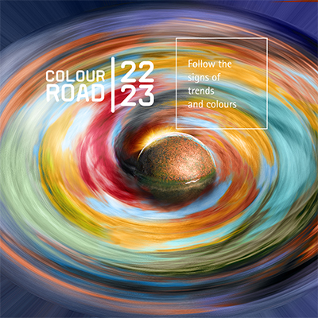
Image „RENOLIT_Colour_Road“
In annual trend reports, RENOLIT's Colour Road Trendservice defines the trend colours for the coming season.

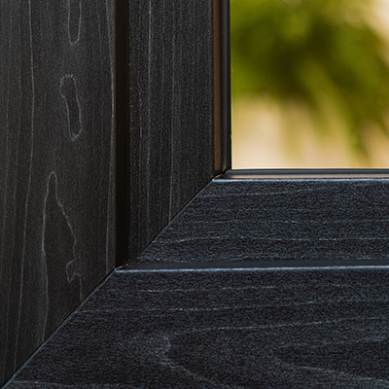
Image „RENOLIT_EXOFOL_PX_Yakisugi“
The new RENOLIT EXOFOL PX Yakisugi décor is based on an old traditional Japanese technique for preserving wood.

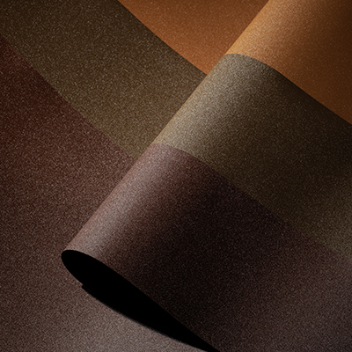
Image “RENOLIT_EXOFOL_PX_Matt_Collection“
With a total of 19 colours, the new RENOLIT EXOFOL PX Matt Collection satisfies the continuing trend for matt surfaces.

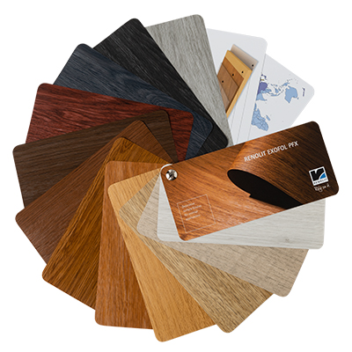
Image „RENOLIT_EXOFOL_PFX_Super-Matt“
The new décors of the RENOLIT EXOFOL PFX Super-Matt collection confirm the popularity of oak.

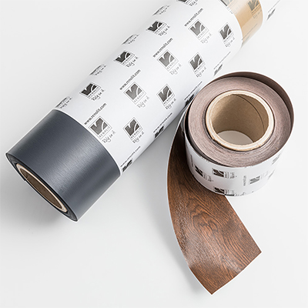
Image „RENOLIT_EXOFOL_repair_film”
With customised repair films, the RENOLIT Film Service reduces the workload for the customer.

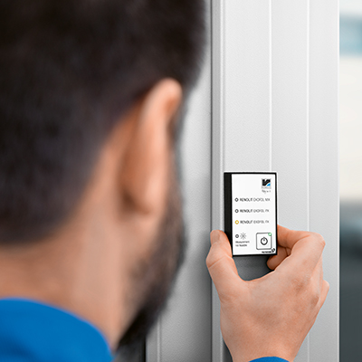
Image „RENOLIT_EXOFOL_Detector“
The detector can now also be used to identify the individual RENOLIT EXOFOL product qualities.

All images: RENOLIT SE

The company
The RENOLIT Group is a globally active specialist for high-quality plastic films, sheets and other polymer solutions. With more than thirty production sites and sales units in over twenty countries, and with annual sales of EUR 1,032 billion in fiscal year 2020, the company with headquarters in Worms – around 70 km south of Frankfurt-am-Main – is one of the world’s leading plastic products manufacturers. More than 4,800 employees continue to further develop the knowledge and expertise gained from seventy-five years of business.
www.renolit.com ꟾ Twitter ꟾ Facebook ꟾ Linkedin

